**Flux plot for problem 4 :**

With different mesh sizes J=[8, 16, 64, 2000, 5000].

In the figure, the last two curves are almost identical. J=64 curve is close enough to the 2000 and 5000 curves.

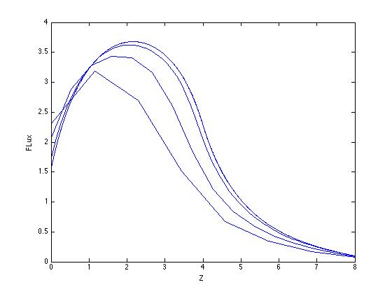

**Flux plot for problem 5 :**

The curve is symmetric because the problem is symmetric.

